**TITLE 4**

**Harnessing Artificial Neural Networks (ANN) for Hazardous Insect Identification compared with densenet algorithm.**

G ABIRAMI1,JOTHISRI 2

G ABIRAMI1

Research Scholar,

Department of Information Technology,

Saveetha School of Engineering,

Saveetha Institute of Medical And Technical Sciences,

Saveetha University,

Chennai,

Tamil Nadu,

India,

Pincode: 602105.

192121095.sse@saveetha.com

JOTHISHRI2

Professor,

Project Guide, Corresponding Author,

Department of Information technology,

Saveetha School of Engineering,

Saveetha Institute of Medical And Technical Sciences,

Saveetha University,

Chennai,

Tamil Nadu,

India,

Pincode: 602105,

jothishrisankar.sse@saveetha.com

**ABSTRACT:**

Agriculture is one of the most important sources for human food throughout the history of humankind.The fact that insecticidal pests impair significant agricultural productivity has become one of the main challenges in agriculture. Insect pests are one of the main factors affecting agricultural crop production. With the advances of computer algorithms and artificial intelligence, accurate and speedy recognition of insect pests in early stages may help in avoiding economic losses in short and long term. In this paper, an insect pest recognition based on deep transfer learning models will be presented. In order to increase the accuracy of recognizing these insects, this research suggests a novel method that combines Artificial Neural Network (ANN) techniques with the Densenet algorithm.

**Keywords:**: Agriculture, Insect pests, Crop, Artificial intelligence, Recognition, Deep transfer learning, Artificial Neural Network (ANN), Densenet algorithm.

**1.Introduction:**

Agriculture is the first people activity that helped humanity to advance and develop.Insect pests have always been considered a serious challenge that affects crop production. The major impact of insect pests is reducing the food available to peoples by ultimately decreasing crop production. . Detecting insect pests plays a critical role in agricultural pest forecasting. Agricultural experts usually detect insect pests manually.For farmers this manual technique needs a high cost . Therefore, it is necessary to find an efficient and rapid technique for automatic insect pests’ classification and detection. In order to identify dangerous insects, this study contrasts the performance of the Densenet algorithm with Artificial Neural Networks (ANN). We assess the performance indicators of both models after training them on a wide range of insect picture datasets. Our results show that the accuracy and efficiency of the ANN-based framework are better than that of the Densenet approach. This study demonstrates how artificial neural networks (ANNs) can accurately and quickly identify insects, which can greatly aid in pest control and environmental conservation initiatives.

**2.METHODOLOGY**

The current experimentation work has been carried out in the Machine Learning Laboratory at Saveetha School of Engineering, Saveetha Institute of Medical and Technical Sciences (SIMATS), Chennai. The sample size has been calculated using the ClinCalc tool under supervised learning with an alpha value of 80%, or 0.8, a G-power value of 0.8, and a significance value of 0.05 at a Confidential Interval (CI) of 95%. The sample size of 20 sets has been used for both Group 1, i.e., Artificial neural network (ANN), and Group 2, i.e., Convolutional neural network algorithm, with a total of 40 sets being considered for this research paper.

**2.1 ARTIFICIAL NEURAL NETWORK:**

ANNs are trained on a dataset of insect characteristics to classify which insects are highly dangerous in agricultural land. ANNs analyze data on insect characteristics collected from agricultural land to identify highly dangerous insects. The dataset is preprocessed, and relevant features are selected. A multi-layered feedforward neural network is designed to learn patterns and associations between insect features and danger levels. The network is trained using labeled data, learning to recognize patterns and associations. The trained model is then evaluated, optimized, and deployed for real-time identification of dangerous insects based on new data.

**Pseudocode for ANN:**

1.Initialize the neural network architecture

2. Initialize the network parameters

3. Choose an appropriate activation function for the neurons

4. Split the dataset

5. Train the neural network

6. Validate the network

7. Test the network:

8. Fine-tune the hyperparameters

9. Report the finding\

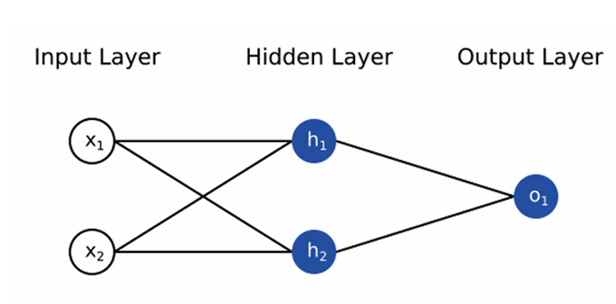

Figure 2.1.1: Artificial Neural Network

**2.2 DENSENET:**

Recent work has shown that convolutional networks can be substantially deeper, more accurate, and efficient to train if they contain shorter connections between layers close to the input and those close to the output. In this paper, we embrace this observation and introduce the Dense Convolutional Network (DenseNet), which connects each layer to every other layer in a feed-forward fashion.DenseNets have several compelling advantages: they alleviate the vanishing-gradient problem, strengthen feature propagation, encourage feature reuse, and substantially reduce the number of parameters.

**Pseudocode for DENSENET:**

1. Define the initial convolutional layer:
2. Define the dense blocks:
3. Define the transition layers (optional)
4. Define the final layers:
5. Compile the model and define the loss function and optimizer.
6. Train the model on the training data.
7. Evaluate the model on the test data.

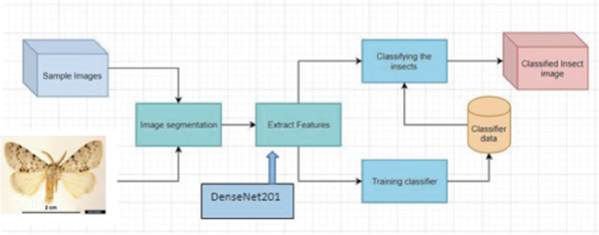

Figure 2.2.1 Insect deduction using Densenet

**3.IMPLEMENTATION:**

Classification methods for rice insect pest images by using deep learning techniques approaches many techniques. Firstly, we introduced a new encoder–decoder in the FCN and a series of sub-networks connected by jump paths that combine long jumps and shortcut connections for accurate and fine-grained insect boundary detection. Secondly, the network also integrates a CRF module for insect contour refinement and boundary localization, and finally, a novel DenseNet framework that introduces an ECA is proposed, focusing on extracting insect edge features for effective rice pest classification. The proposed model was tested on the data set collected in this paper with a final accuracy of 98.28%, showing a better performance than existing methods. Moreover, the model in this paper also maintains high model accuracy with good robustness in the classification of small target insects and insects with the same physical characteristics, while it can be demonstrated from our results that effective segmentation of insect images prior to classification can improve the detection performance of deep-learning-based classification systems.

**3.1Dataset Collection :**

The dataset was gathered from the Kaggle website, an open-access platform that many data science and machine learning students have utilized for different kinds of research. The present dataset is named Dangerous insects dataset. The data source link is: [Dangerous Farm Insects Dataset (kaggle.com)](https://www.kaggle.com/datasets/tarundalal/dangerous-insects-dataset).

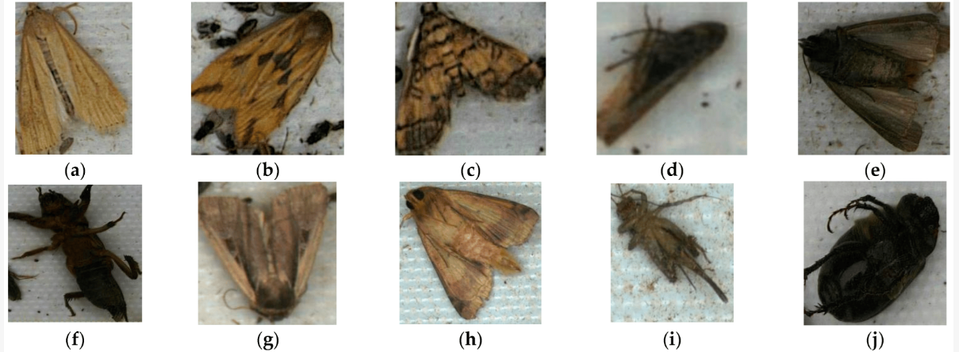

**Figure 3.1.1.** Examples of pest images: (**a**) *C. suppressalis*, (**b**) *N. aenescens*, (**c**) *C. medinalis*, (d) *N. lugens*, (**e**) *A. ypsilon*, (**f**) *G.* sp, (**g**) *M. separata*, (**h**) *H. armigera*, (**i**) Gryllidae, (**j**) *H. diomphalia*.

**3.2Testing set-up:**

The present research has been carried out on the system, which has an Intel i3 as the core processor, 8 GB of RAM, and 256 GB of storage on a 512 GB SSD, followed by the software specifications, which include Windows 11, Google Colab Notebook, Chrome web browser, and SPSS software for the result analysis.. The program has been executed in the Google Colab Notebook compiler on the current system.

3.3**Testing procedure :**

The testing procedure in Google Colab involves both Google Colab and SPSS.

In Google Chrome, log in to Google Colab Notebook. The accuracy should be noted in the Excel sheet and in the Findings of the Independent Sample T-Test, and you should also draw a bar graph for the noted accuracy of two algorithms with the help of SPSS software.

​3.4 **Statistical Analysis:**

IBM SPSS 26 programming is utilized for factual examination of ANN and Inception algorithm calculation based techniques. Key performance metrics include accuracy, precision, recall, and F1 score—each providing a different perspective on model effectiveness. Comparative results demonstrate the superiority of one approach over the other, in specific conditions and scenarios encountered in crop fields.

**4.DECLARATIONS**

**Conflict of Interests**

There are no conflicts of interest disclosed in this work. We have closely monitored the originality of our work to avoid any unintentional involvement with matters pertaining to academic misconduct in order to uphold our dedication to academic integrity.

**Acknowledgement**

The authors would like to express their gratitude towards Saveetha School of Engineering and Saveetha Institute of Medical and Technical Sciences (formerly known as Saveetha University) for providing the necessary infrastructure to carry out this work successfully.

**Authors Contribution**

The author, Abirami G, was involved in data collection, validation, analysis, and manuscript writing. Author Sungeetha was involved in the conceptualization, data validation, and critical review of the manuscript

**Funding**

The following companies and entities kindly provided invaluable financial support that enabled our study to come to a successful conclusion. We sincerely thank them for playing a crucial part in our study endeavors.

**1. Saveetha University.**

**2. Saveetha Institute of Medical And Technical Sciences.**

**3. Saveetha School of Engineering.**

**5. RESULT ANALYSIS :**

* 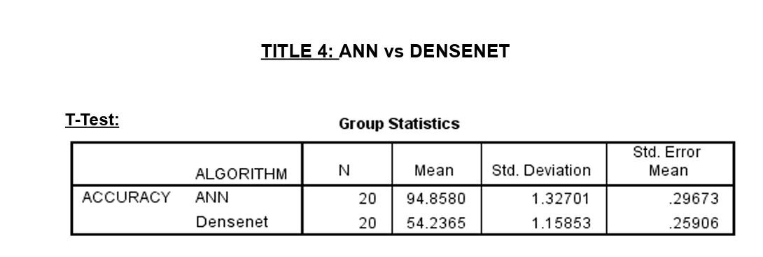

**In Table 1,** it has been observed that the accuracy of the Artificial neural network (ANN) algorithm and the Densenet algorithm.

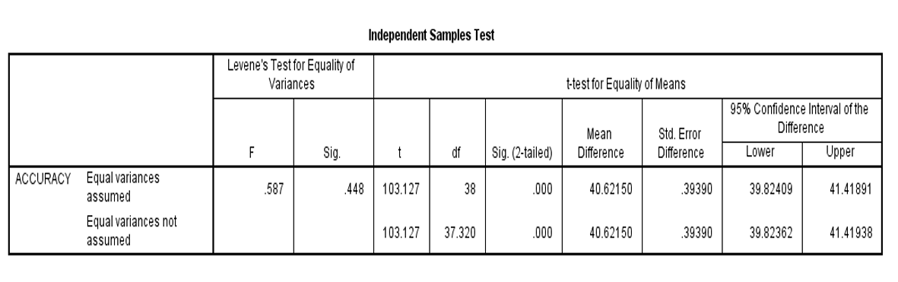

**In Table 2,** The statistical analyses like mean, standard deviation, and standard error mean have also been calculated for the artificial neural network algorithm and for the Densenet algorithm.

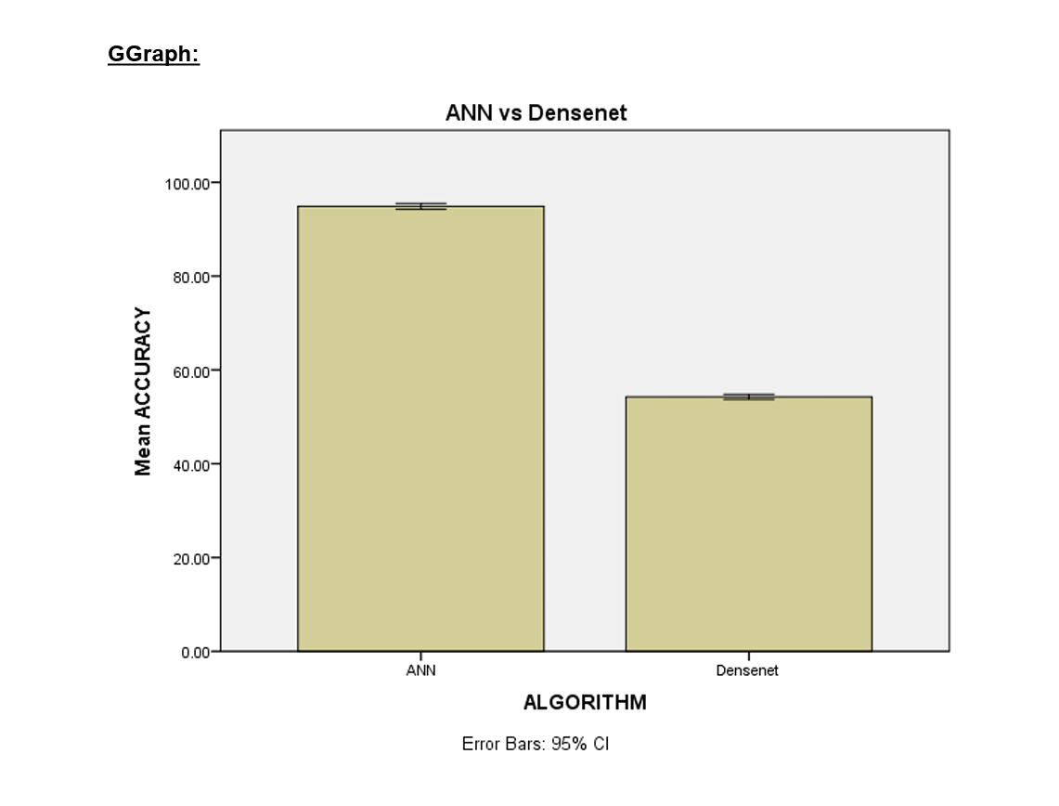

**Table 3.** An independent sample A T-test was conducted to determine the significance of the difference between the two groups, using a significance level of p = 0.000 (p<0.05), indicating that the difference is statistically significant.

**6.CONCLUSION:**

In conclusion, the integration of deep transfer learning models presents a potential method for the quick and reliable identification of insect pests in agriculture. This is especially true when combining Artificial Neural Network (ANN) techniques with the Densenet algorithm. This novel approach has the potential to reduce financial losses brought on by pest damage, supporting food security and sustainable crop production in the process. In order to improve pest management tactics and guarantee the resilience of agricultural systems against insect pests, further study and application of such techniques are imperative as computer algorithms and artificial intelligence progress.

**7.REFERENCES:**

**1.**S. Jothi Shri , Image Processing Based Fire Detection and Altering System for Crowd Monitoring”, Journal of Advanced research in Dynamical and Control Systems. pp- 280-286, Vol. 11, 2019.<http://www.jardcs.org/abstract.php?id=285>.

2.S.Jothi Shri,A secure and effective data aggregation in WSN for improved security and data privacy-**i**,[A secure and effective data aggregation in WSN for improved security and data privacy | Review of Computer Engineering Research (conscientiabeam.com)](https://archive.conscientiabeam.com/index.php/76/article/view/3494).

3.<https://www.mdpi.com/2073-4395/13/2/410> Based on FCN and DenseNet Framework for the Research of Rice Pest Identification Methods.

4.Insect Recognition and Classification Using Optimized Densely Connected Convolutional Neural Network<https://link.springer.com/chapter/10.1007/978-3-031-25344-7_23>.

5.Detection and Identification of Stored-Grain Insects Using Deep Learning: A More Effective Neural Network<https://ieeexplore.ieee.org/abstract/document/9186676/>

6.INSECT PESTS RECOGNITION BASED ON DEEP TRANSFER LEARNING MODELS https://ieeexplore.ieee.org/document/10058692.

7.<http://www.journal-iiie-india.com/1_feb_23/20.pdf>,

DETECTION OF PEStS iN AGrICULTURe farMS USING MODIFIED DENSENET DEEP LEARNING MODEL.

8.<https://www.sciencedirect.com/science/article/pii/S0959652622032164>,

Plant Diseases and Insect Pests Recognition Algorithm Based on D-YOLOv3.

9.<https://www.researchgate.net/publication/346041584_Detection_and_Identification_of_Stored-Grain_Insects_Using_Deep_Learning_A_More_Effective_Neural_Network>.

Detection and Identification of Stored-Grain Insects Using Deep Learning: A More Effective Neural Network.

10. X. Wu, C. Zhan, Y.-K. Lai, M.-M. Cheng, and J. Yang, “Ip102: A large scale benchmark dataset for insect pest recognition,” in Proceedings of the IEEE/CVF Conference on Computer Vision and Pattern Recognition, 2019, pp. 8787–8796.

11.Insect biodiversity and their conservation for sustainable ecosystemfunctioning,<https://www.researchgate.net/publication/355583803_Insect_biodiversity_and_their_conservation_for_sustainable_ecosystem_functioning>.